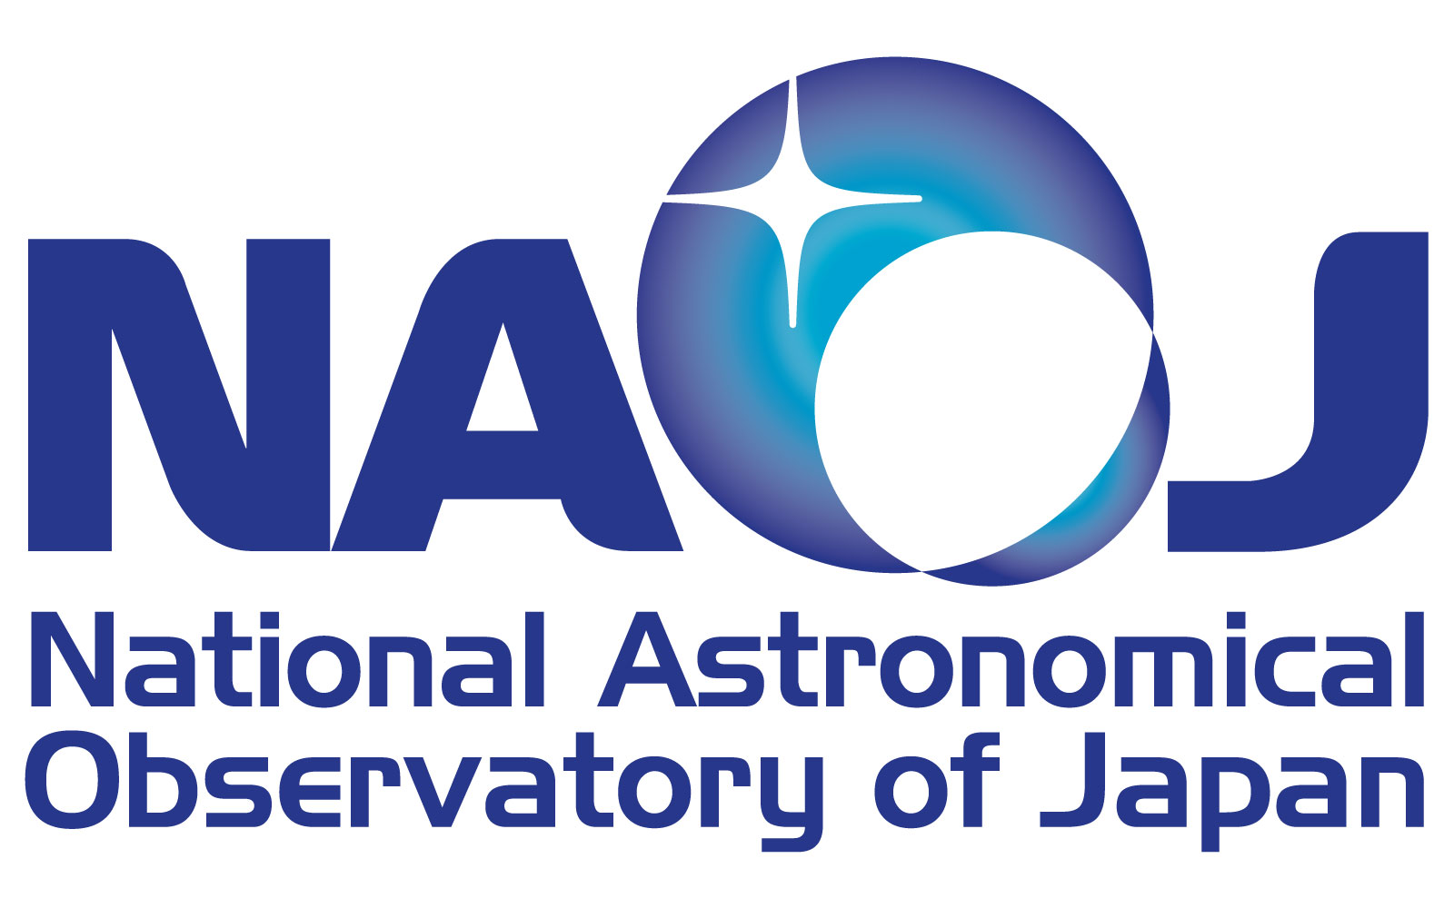 | The 5th EACOA Meeting  07 – 08 November 2011  Kyoto University, Kyoto, Japan
ATTENDANCE FORM
(Please fill out and return this form by October 15, 2011)
PERSONAL INFORMATION :
(Mr./Ms./Mrs/Dr./Prof.) Last Name___________________ Middle Name First Name
Institution/Organization
Business Address
City / Postcode _____________________________________ Country___________ _____________
Phone No._________________ ___ Fax No:__________________________ _
E-mail address: ________________________________________________
PASSPORT INFORMATION FOR VISA: (Not necessary if Visa is not Required)
Passport No.____________________ Date of Issue_________________ Expiry Date
Place of Issue: __________________ Date of Birth _______________ Place of Birth ___________________
FLIGHT INFORMATION:
Arrival Flight: (Flight No./Date/Time) ________________/___________________/__ ____
Departure Flight:(Flight No./Date/Time) ________________/___________________/__ ____
HOTEL ACCOMMODATION: Booking will be handled by the Office of International Relations.
Hotel: Kyoto Royal Hotel & Spa (http://www.ishinhotels.com/kyoto-royal/en/index.html)
Address: Sanjo-Agaru, Kawaramachi, Nakagyo-ku, Kyoto 〒604-8005
Tel：+81-75-223-1234 Fax：+81-75-223-1702
Please tick your preference.
 Superior Semi-Double room (JPY 11,500 / night, Bed Only, Breakfast JPY1,500)
 Superior Double room (on request)
 Superior Twin room (on request)
 Business Suite room (on request)
 Smoking  Non-Smoking
Check In Date: ___________________________ Check Out Date: ____________________________

For Twin booking, I will share with ________________________________________________________
Additional Information / Requests (If any):
Please Return To: Office of International Relations
National Astronomical Observatory of Japan, 2-21-1 Osawa, Mitaka, Tokyo 181-8588 Japan
Fax:+81 422 343778 Email: irc@nao.ac.jp

